BIO-DATA
NAME :- DR. INDRAMAN SINGH CHANDRAKER
Date of birth :- 09/07/1956
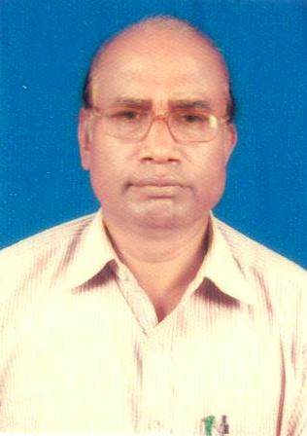
Post Held : - Professor & Head,
(At Present) Department of Geography
Govt. V.Y.T. P.G. (Autonomous)
College Durg (C.G.)
Post Held :- I/C Principal
(In the past) Govt. Eklavya College
Dondi Lohara ,Dist- Balod (C.G.)
(From a 24/08/2012 to 16/08/2017)
National/International Seminar /Symposium Attended:
National | 10
International | 02

Life member of several leading learning societies :
a). Transaction, journal of the institute of Indian geographars, department of geography university of pune -411007
b). Uttar Pradesh geographical journal, the brahmavarta geographical society of india, 124 C-1, indira nagar, Kanpur -208026 (india)
c). Research Strategy, Department of Geography VSSD College CSJM University , Kanpur (U.P.)
d). Research fronts, Govt.Digvijay P.G. Autonomous College Rajnandgaon , C.G. 491441 india.

Research paper published :-
SI. NO. | Name of Geographical Journal | Research paper Published
01  02  03  04  05  06  07 | Uttar Pradesh Geographical Journal Vol. 6,2001  Uttar Pradesh Geographical Journal Vol. 7,2002  NRrhlx<+ foosd] vad &3 fnlacj 2002 Qjojh 2003-  ‘kks/k izdYo ] Vol. XXIII NO. 02 April- June 2003.  Uttar Pradesh Geographical Journal Vol. 10,2005  Research Strategy Vol. III Dec. 2013  Research Strategy Vol. IV Dec. 2014 | lekfUor xzkeh.k fodkl gsrq ;krk;kr fu;kstu] vkfnoklh fodkl [k.M ckyksn tuin nqxZ dk ,d izrhd v/;;u A  Hkkjr ds lanHkZ es {ks=h; fodkl fu;kstuA  fodkl [k.M ckyksn ftyk nqxZ (NRRkhlx<+) es Qly pdZ ifjoRkZu ds fo’ks”k lanHkZ es frygu Qlyksa ds mRiknu dh laHkkouk,WA  NRRkhlx<+ izns’k dh tula[;k o`f/n dh lkekftd izo`fRr;ka ,d HkkSxksfyd fo’ys”k.kA  dkaxzl dk fujk’kktud izn’kZu ] yksdlHkk pquko &2004 NRrhlx<+ izns’k ds fo’k”k lsnHkZ esaA  xzkeh.k Hkwfe mi;ksx fodkl ,oa fu;kstu ]nqxZ rglhy (NRRkhlx<+) ,d izrhdkRed v/;;UakA  d`”; catj Hkwfe fodkl ,oa fu;kstu %nqxZ rg- (NRRkhlx<+)ds fo’ks”k lanHkZ esa
Book Published :-
O;kogkfjd Hkwxksy] olqU/kjk izdk’ku ] 236] nkmniqj xksj[kiqj mRrj izns’k 1998-
A minor Research Project Report on Cultivable Wasteland Development and Planning in Durg Tahsil, C.G. Geographical Reference, Submitted to University Grants Commission, 2011

